Temperature Probe Calibration Safety Report
Calibration of a digital temperature probe and measurements of the heat dissapation of electronic components

Date: | 19/05/2026
Student & SU nr: | Pieter Breytenbach, 26122146
Student contact nr: | 078 780 9388
Supervisor: | Prof K Schreve
Lab engineer: | Mr K Neaves
Head of safety: | Mr Cobus Zietsman

Emergency Contacts:

Contact: | Room nr. | Work nr. | Cell nr.
Mr K Neaves | M239 | 021 808 4279 | -
Mr C. Zietsman | M212 | 021 808 4275 | -
Campus Security | - | 021 808 2333 | WhatsApp:  082 808 233
Fire Brigade | - | 021 808 8888 | -
Ambulance | - | 021 883 3444 | -

Signatures:

Student:  (PW Breytenbach) | 
Supervisor:
(K Schreve)
Lab Engineer:
(K Neaves)
Head of Safety:
(C Zietsman)

Pressure vessels or pipes (check relevant box):
☒ No pressure vessels or pipes with pressure in excess of 50kPa are involved in this project.
☐ Pressure vessels or pipes in excess of 50kPa are involved – additional signature and report required (refer to Safety Report Guidelines on SUNLearn).

Hot work / working at heights / confined entry / excavation (check relevant box):
☒ No hot work / working heights / confined entry / excavation work involved in this project.
☐ Hot work / working heights / confined entry / excavation work (underline relevant work type(s)) involved in this project – additional signature and report required (refer to Safety Report Guidelines on SUNLearn).

Overview of Temperature Probe Calibration Testing

Type of test and standard (if applicable):

Test type | Temperature Probe Calibration
Standard(s) | N/A

Equipment to be used:

Equipment type | Make & model | Measurement range (if applicable) | Resolution (if applicable)
Digital Thermometer | DS18B20 | -10 °C – 85 °C | ± 0.5 °C
Microcontroller | Raspberry Pi Pico 2W | N/A | N/A
Resistors | N/A | N/A | N/A
Calibrated Thermometer | Type T Thermometer | -25 °C – 220 °C | N/A
Container | N/A | N/A | N/A

Detailed Experimental Procedure: Calibration Test

The purpose of this test is to calibrate the digital temperature probes that will be utilized in the Raspberry Pi Laparoscope product. They are essential to prevent harm to the physical components of the laparoscope due to overheating. It will also be beneficial to determine how much heat electronic components generate.
In order to calibrate the digital temperature probes, the measured temperatures will be compared to an already calibrated temperature probe to reduce the error margins of the temperature probes.

Setup procedure for calibration test of digital probes:

- The operator must read through the safety report before the test can be started.
- The operator must secure the temperature probes in the 3D printed frame to ensure the temperature probes do not shift during the operations.
- Check that the wiring of the test is according to the wiring diagram for the test.
- Check that the program for the microcontroller is the correct one.
- The operator should measure the room temperature of the laboratory.
- Retrieve different temperatures of water (warm (≈60 °C) and ice cold), which will be used in different iterations of the experiments.

Testing procedure for the calibration test of the digital probes:

- Fill the container with warm water to the designated water height limit.
- Secure the 3D printed frame, with the secured temperature probes, over the container, ensuring that the temperature probe’s bodies are in contact with the water, but not fully submerged.
- Insert the calibrated thermometer into the container, ensuring that it is at the same depth as the temperature probes.
- Wait a duration of 2 minutes to ensure that the water in the container has reached a uniform temperature across the entire container.
- Measure the temperature across each of the probes and the calibrated thermometer for a duration of one minute.
- Wait a duration of 5 minutes (allow the water to cool down for the next measurement) before repeating step 5.
- Repeat steps 5-6 until the water is within ±5 °C of the room temperature.
- Remove the temperature probes and calibrated thermometer from the container and use a towel to dry them off.
- Discard the water from the container in the appropriate facilities and properly dry the container.
- Fill the container with the ice-cold water to the designated water height.
- Secure the 3D printed frame, with the secured temperature probes, over the container, ensuring that the temperature probe’s bodies are in contact with the water, but not fully submerged.
- Insert the calibrated thermometer into the container, ensuring that it is at the same depth as the temperature probes.
- Wait a duration of 2 minutes to ensure that the water in the container has reached a uniform temperature across the entire container.
- Measure the temperature across each of the probes and the calibrated thermometer for a duration of one minute.
- Remove the temperature probes and calibrated thermometer from the container and use a towel to dry them off.
- Discard the water from the container in the appropriate facilities and properly dry the container.

Shut-down procedure for calibration test of the digital probes:

- Discard any remaining liquid in the proper facilities.
- Carefully remove the temperature probes from the 3D printed bracket.
- Pack everything away in its appropriate containers.
- Clean the surface of any remaining debris.

Overview of Temperature Probe Calibration Testing

Type of test and standard (if applicable):

Test type | Heat Dissipation Measurements
Standard(s) | N/A

Equipment to be used:

Equipment type | Make & model | Measurement range (if applicable) | Resolution (if applicable)
Digital Thermometer | DS18B20 | -10 °C – 85 °C | ± 0.5 °C
Microcontroller | Raspberry Pi Pico 2W | N/A | N/A
Resistors | N/A | N/A
Container | N/A | N/A | N/A
Camera module | OV9734 endoscope | N/A | N/A
LED assembly | LED SMD 1206 | N/A | N/A

Detailed Experiment Procedure: Heat Dissipation Test

The purpose of this test is to determine the heat generated by the camera module and LED assembly that will be attached to the tip of the laparoscope. This value is essential to determine the digital module of the heat transfer of the entire system. It would also provide insight into the requirements for the heat pipes, heat sinks, and axial fans to be able to cool the system properly to prevent damage to the different components.

Setup procedure for the heat dissipation test:

- The operator must read through the safety report before the test can be performed.
- Check that the wiring of the test is according to the wiring diagram for this test.
- Check that the program on the microcontroller is the correct program.
- Check that the DC power supply is providing the correct voltage.
- Check that the resistors and LED assembly are giving the correct voltage readings.

Testing procedure for the heat dissipation test:

- Power on the camera module and LED assembly.
- Insert the camera module, temperature probe, and LED assembly into the container.
- Close the lid of the container and fill any air gaps with Prestik.
- Run the microcontroller program. (Program will measure the temperature inside the container every 10 minutes for a duration of 2 hours)
- If the temperature reaches the designated maximum tolerable threshold before the 2 hours have elapsed turn off the power to the camera module and the LED assembly.
- Do not disturb the container until the program is finished.
- Once the program is finished, the modules can be turned off before the LID is removed and all its content within the container as well.

Shut-down procedure for the heat dissipation test:

- Power off the DC voltage supply.
- Remove all wiring
- Clean the surface of any debris.

Warning Symbols
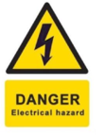

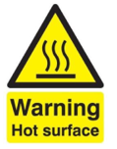
Figure 1: Hot Surface Warning

Figure 2: Electrical Hazard
Figure 3: General Warning


Figure 4: Wet/Slippery warning

General Laboratory Safety

The following general laboratory safety instructions are applicable:
- No afterhours testing may be performed without the necessary permissions.
- Full supervised training is required before testing may be undertaken. Permission to proceed with unsupervised testing should be signed off by the lab engineer.
- Closed shoes must be worn at all times.
- Emergency equipment must be located and easily accessible.
- Students may not work alone in the laboratory.
- Emergency exits must be known. The nearest exits applicable to the setup are provided in Appendix A of this document.
- Loose clothing may not be worn. Loose hair must be tied up.
- Good housekeeping practices should be maintained during testing. The lab should be completely clean, including all equipment stored away, after testing. Refer to the General Housekeeping section for particulars regarding practices to be followed for this specific setup.
- No food or drink is permitted in the laboratory.
- Safety report must be visible and accessible during testing.
- No equipment or test may be left unattended.

Anticipated Interactions with Other Laboratory Users

The planned testing will occur in the mechatronics laboratories. Since the tests are planned to happen during university examination periods, there should be minimal to no possible interactions with other undergraduate students. There is, however, a chance for interactions with possible post-graduate students and the laboratory manager, Mr K Neaves. These interactions will be kept to a minimum. Mr K Neaves will be notified of the planned experiments and when they are planned to take place.

General Housekeeping

All the standard laboratory rules will be followed, e.g., no eating in the laboratories. In case there is any water spillage, the surface will be cleaned and dried properly. The entire workstation will be cleaned after all the experiments are performed and the equipment is packed away. The calibrated thermometer will be returned to the appropriate laboratory manager once the experiments have been concluded. If any damage is discovered to the thermometer or the DC power supply, it will be reported to the appropriate laboratory manager.

Fire Safety

The second test requires the operator to leave the LED assembly and camera module to generate heat, which is a risk. This risk is, however, mitigated through several methods. The first mitigation method is to determine where the closest fire extinguisher is, in case of a fire. The second mitigation method is to not allow the components to reach beyond a specified limit, which is 50 °C. If the specified limit is reached, it will send a warning message to the operator, who will then shut off the power to the entire system. Additionally, the fire evacuation route is also studied in case a fire does break out in the laboratories. A copy of the route is pasted in the appendix.

Activity-Based Risk Assessment

The following risks and mitigating steps are associated with certain activities associated with this experimental setup and procedure:

Activity | Risk | Risk Type* (P/E) | Mitigating Steps | Classification of Risk Severity
General
Moving around in the lab | Tripping or bumping into a different workstation | P | Always be aware of your surroundings when moving around in the laboratories and never use your own personal cell phone when moving around. | Acceptable
 | Slipping on water | P | Ensure that no water is spilled from the containers | Acceptable
Turning on the DC Power supply | Electrical shock | P/E | Check the wiring diagram and the wire insulation and the connections. | Possible
 |  |  | Wear closed shoes
Power Outages | Damage to the equipment or invalid data measurements | E | Be aware of load shedding schedules and turn off all equipment in case of power outages | Possible
Personal valuables in the laboratory | Theft of the valuables from the laboratory | P | Do not bring unnecessary valuable items to the laboratory sessions. Valuables that are brought should be placed in a safe location | Acceptable
Tidying lab | Cuts from the wires | P | Be aware of the cable ends when de-wiring the test | Possible
Stripping wires | Cuts from the wires | P | Be aware of the cable ends | Possible
 | Cuts from the equipment | P | Careful use of the wire strippers | Possible
Wiring the system | Cuts from the wires | P | Be aware of the cable ends and connections | Possible
Moving around with hot water | Burns from the hot water | P | Keep the water in a closed, lidded container while moving | Acceptable
Calibration Test
Securing the probes to the 3D printed parts | Physical damage to the probes | E | Careful use of the probes, do not exert excessive force when securing them | Possible
Adding the ice-cold water | Damage to the probes | E | Ensure that no ice cubes are thrown into the container | Possible
Securing the 3d printed part over the container | Water damage to the probes | E | Ensure the water height limit in the container is not exceeded | Possible
 |  |  | Ensure the probes are properly secured
During the measurements | Water damage to the probes | E | Prevent any vibrations to the testing station | Possible
 | Wiring disconnections | P | Do not interfere with the wiring while the test is being performed | Possible
 | Loss of power | P | Ensure the computer is plugged into the grid and the microcontroller is securely plugged into the computer | Possible
Inserting/removing the calibrated thermometer | Water damage to the probes | E | Insert/removing the calibrated thermometer slowly into the container | Possible
Removal of used water | Water damage to the lab | E | Be aware of the environment when moving around and keep the used water in a closed lidded container | Possible
Removing the 3D printed part from the container | Water damage to the probes | E | Ensure the part is removed carefully | Possible
Data saving | Loss of data | E | Check that the data is saved properly | Possible
Heat Dissipation Test
Turning the LED on | Damage to the LED | E | Check that the DC power supply does not exceed the limit | Possible
 |  |  | Check that the LED turns on
 |  |  | Check the continuity of the LED
Closing the lid of the container | Damage to the cables | E | Check that cables are not pinched | Possible
 | Heat Leakage | P | Use the Prestik to fill in the gaps of the container lid | Possible
During the measurement | Loss of Power | P | Periodically check that the DC power supply is active, the microcontroller is on, and that the camera is active | Possible
 | Heat damage | E | Periodically check that there aren’t any warnings from the program | Possible
Data saving | Loss of the data | P | Check that the data is properly saved | Possible
*P – personal, E - equipment

Disciplinary Actions
Failure to comply with any of the aforementioned safety regulations or procedures will result in disciplinary action. Students will be issued an initial warning: after three warnings, the lab access is revoked for a month.

Appendix A: Emergency Evacuation Plans
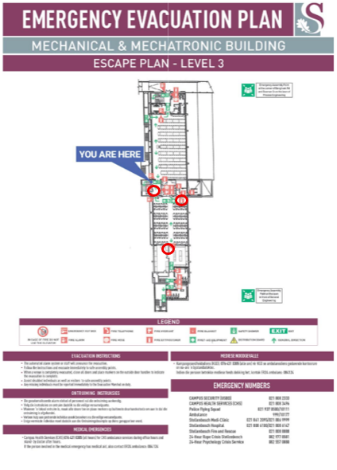

Appendix B: Wiring diagram for test 1

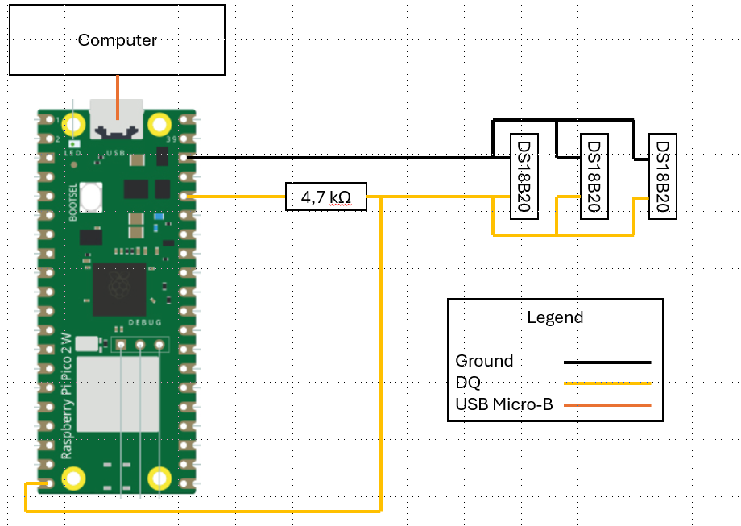

Appendix C: Wiring diagram for test 2

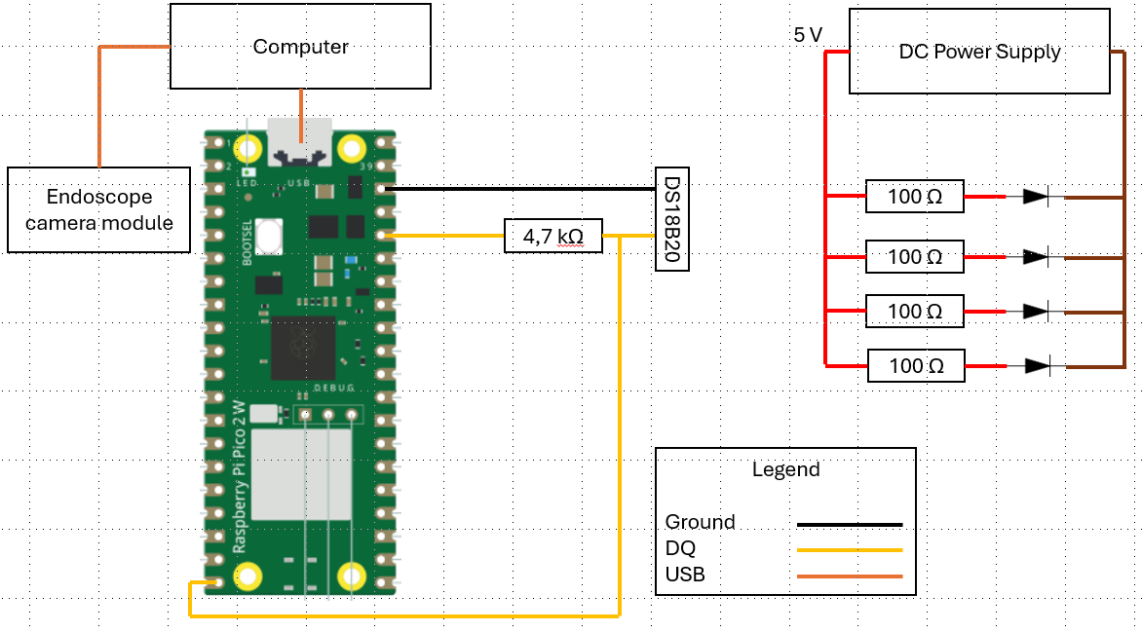

Written permission from supervisor and approved by the chief safety officer. Attach proof of this permission to this document and note here the times and conditions of the arrangement.

